[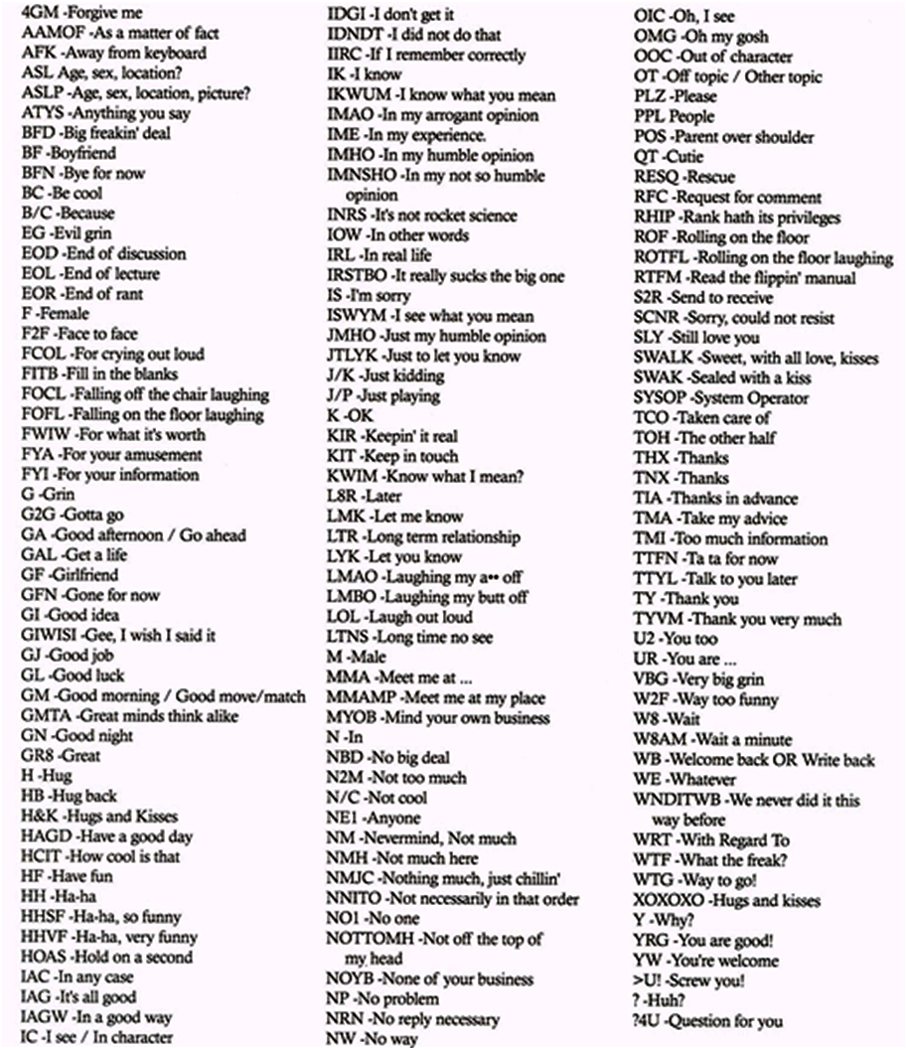](https://www.google.com/url?sa=i&rct=j&q=&esrc=s&source=images&cd=&ved=0ahUKEwj0m5C3jufPAhWF2T4KHX-FCA8QjRwIBw&url=https://www.pinterest.com/colwell458/texting/&psig=AFQjCNHvdodUnSL0XQIriXigrM05N3s7sA&ust=1476974894415990)